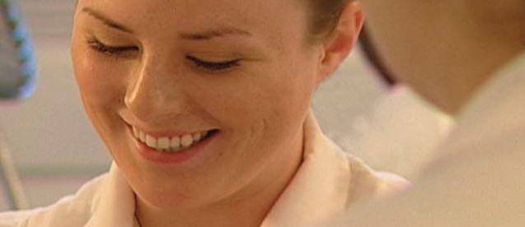A CAREER IN ESTHETICS

YOU ARE ABOUT TO EMBARK ON A NEW JOURNEY.

WE’LL BE THERE TO HELP EVERY STEP OF THE WAY.

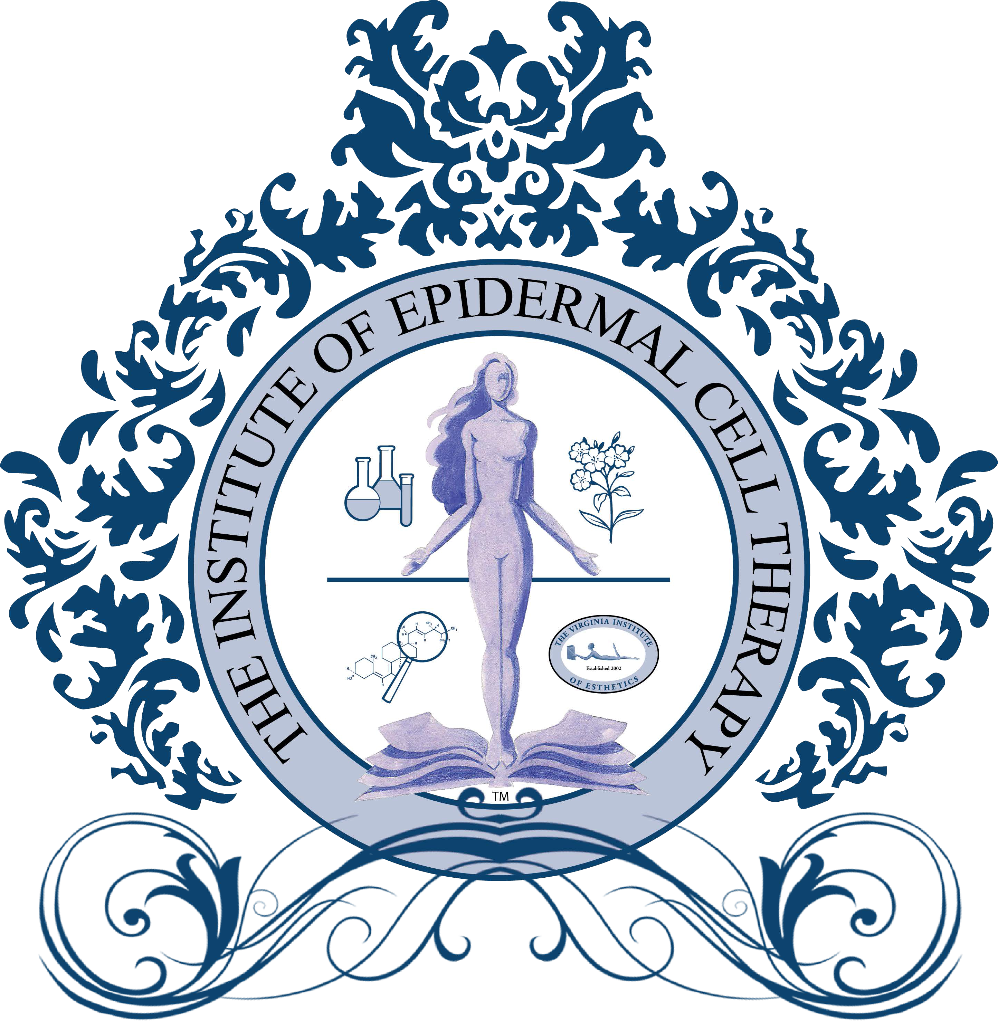

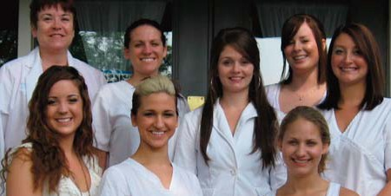

A PROMISING FUTURE

Skin care can be traced back 6,000 years to ancient Egypt.
It was initially associated with the practice of medicine, and at that time,
both priests and physicians had important roles.

Cosmetic products included ingredients such as special soils, wax, honey and oil, formulated into masks and makeup.

While skin care waned in the Middle Ages, the Renaissance in Europe brought back a renewed interest in both the skin and cosmetics.

With the turn of the 20th century and up until the 1960’s, skincare often involved the use of heavy cosmetics to camouflage imperfections and blemishes.

Today, the emphasis for skin care has shifted from “coverup,”
to a more natural look, which is only truly attractive with healthy, clean skin.
This has expanded the desire for skin care treatments and the future for estheticians.

According to CNN.com, “skin care specialist” is ranked number 4 out of the 10 top jobs in the service occupation segment, and is expected to experience continued strong growth and demand in the coming decade.

As reported in Skin Inc. magazine issued May 2008, “Good education is vital to the training of skilled technicians who are expected to meet the needs of a growing population.”

Benefits

Indications And Contraindictions (Pros and Cons)

Pre-Procedure (Preparation)

Procedure

Post-Procedure

Maintenance

VIRGINIA DEPARTMENT OF PROFESSIONAL & OCCUPATIONAL REGULATION

Perimeter Center • 9960 Maryland Drive • Suite 400 • Richmond, VA 23233 804-367-8500 • www.dpor.virginia.gov • email: barbercosmo@dpor.virginia.gov
Esthetician means a person who engages in the practice of esthetics for compensation. Esthetics includes, but is not limited to, the following practices of administering cosmetic
treatments to enhance or improve the appearance of the skin: cleansing, toning, per-
forming effleurage or other related movements, stimulating, exfoliating, or performing
any other similar procedure on the skin of the human body or scalp by means of cosmetic
preparations, treatments, any non-laser device, electrical, mechanical, or manual, for are
of the skin; applying makeup or eyelashes to any person, tinting or perming eyelashes
and eyebrows, and lightening hair on the body except the scalp; and removing unwanted
hair from the body of any person by the use of tweezing, chemical, or mechanical means.
Esthetics is not a healing art and shall not include any practice, activity, or treatment
that constitutes the practice of medicine, osteopathic medicine, or chiropractic. The
terms “healing arts”, “practice of medicine”, “practice of osteopathic medicine”, and
“practice of chiropractic” shall mean the same as those terms as defined in § 54.1-2900.

Master esthetician means a licensed esthetician who, in addition to the practice of esthet- ics, offers to the public for compensation, without the use of laser technology, lymphatic drainage, chemical exfoliation, or microdermabrasion, and who has met such additional requirements as determined by the Board to practice lymphatic drainage, chemical ex- foliation with products other than Schedules II - VI controlled substances as defined in the Drug Control Act (§ 54.1-3400 et seq.), and microdermabrasion of the epidermis.

The issue of estheticians practicing in a medical setting has not been addressed at this time.

SVSS CODES BY STATE

State  Alabama | Contact Info  800.815.7453, www.aboc.state.al.us | Educational Hours  1500 | Title  Esthetician | Treatment  Face |  | Medical Setting  Yes
Alaska | 907.465.2534, www.commerce.state.ak.us | 350 | Esthetician | Face |  | No
Arizona | 480.784.4539, www.cosmetology.state.az.us | 600 | Aesthetician | Face |  | No
Arkansas | 501.682.2168 | 600 | Aesthetician | Face |  | Yes
California | 916.323.1101, www.barbercosmo.ca.gov | 600 | Skin Care Specialist | Face |  | Yes
Colorado | www.dora.state.co.us/barbers_cosmetologists | 600 | Cosmetician | Face |  | Yes
Connecticut | 860.509.7569, www.state.ct.us | Not required | Cosmetician | Face |  | Not regulated
Delaware | www.professionallicensing.state.de.us | 300 | Aesthetician | Face |  | Yes
D.C. | 202.442.4320, www.dcra.org | 125 | * | * |  | No Response
Florida | 850.488.5702, www.myflorida.com | 260 | Skin Care Specialist | Face |  | No
Georgia | 912.207.1441, www.sos.state.ga.us | 1000 | Esthetician | Face |  | No
Hawaii | 808.586.3000, www.state.hi.us/dcca | 600 | Esthetician | Face |  | No
Idaho | 208.334.3233, www.ibol.idaho.gov | 600 | Esthetician | Face |  | Yes
Illinois | 217.782.8556, www.idfpr.com | 750 | Esthetician | Face/Body |  | No
Indiana | 317.232.2980, www.ai.org/pla/index.html | 700 | Esthetician | Face |  | No
Iowa | 515.281.4416, www.idph.state.ia.us/licensure | 600 | Esthetician | Face |  | No response
Kansas | 785.296.3155, www.accesskansas.org/kboc | 650 | Esthetician | Face |  | No
Kentucky | 502.564.4262 | 1000 | Cosmetology | Face |  | No
Louisiana | 225.756.3404 | 750 | Esthetician | Face |  | No
Maine | 207.624.8603, www.maineprofessionalreg,org | 600 | Aesthetician | Face |  | Yes
Maryland | 410.230.6320, www.dllr.state.md.us | 600 | Esthetician | Face |  | No
Massachusetts | 617.727.3067, www.state.ma.us/reg | 300 | Aesthetician | Face |  | Yes
Michigan | 517.241.9201, www.michigan.gov/cosmetology | 400 | Esthetician | Face |  | No
Minnesota | 651.297.3839, www.commerce.state.mn.us | 600 | Esthetician | Face |  | No
Mississippi | 601.987.6837, www.msbc.state.ms.us | 600 | Esthetician | Face |  | No
Missouri | 573.751.1052, www.ecodev.state.mo.us/pr | 750 | Esthetician | Face |  | No
Montana | 406.841.2333, www.discoveringmontana.com | 650 | Esthetician | Face |  | No
Nebraska | 402.471.2117, www.hhs.state.ne.us | 600 | Esthetician | Face |  | No
Nevada | 702.486.6542, www.state.nv.us | 600 | Aesthetician | Face |  | No
New Hampshire | 603.271.3608, www.state.nh.us/cosmet | 600 | Esthetician | Face |  | No
New Jersey | 973.504.6400, www.state.nj.us/lps/ca/boards.htm | 600 | Skin Care Specialist | Face |  | No
New Mexico | 505.476.4690, www.rid.state.nm.us.b&c/ | 600 | Esthetician | Face |  | No
New York | 518.474.4429, www.dos.state.ny.us | 600 | Esthetician | Face |  | No
North Carolina | 919.733.4117, www.cosmetology.state.nc.us | 600 | Esthetician | Face |  | Yes
North Dakota | 701.224.9800 | 600 | Esthetician | Face |  | Yes
Ohio | 614.644.6099, www.cos.ohio.gov | 600 | Esthetician | Face |  | No
Oklahoma | 405.521.2441, www.state.ok.us/~cosmo | 600 | Esthetician | Face |  | No
Oregon | 503.378.8667, www.hio.state.or.us | 250 | Esthetician | Face |  | No
Pennsylvania | 717.783.7130, www.dos.state.pa.us/cosmet | 300 | Cosmetician | Face |  | Yes
Rhode Island | 401.222.2511, www.health.state.ri.us | 600 | Esthetician | Face |  | No
South Carolina | 803.896.4830, www.llr.state.sc.us | 450 | Esthetician | Face |  | Yes
South Dakota | 605.773.6193, www.state.sd.us/dol/boards/cos | 600 | Esthetician | Face |  | Yes
Tennessee | 615.741.2515, www.state.tn.us | 750 | Aesthetician | Face |  | Yes
Texas | 512.454.4674, www.txcc.state.tx.us | 750 | Facialist | Face |  | Yes
Utah | 801.530.6628, www.commerce.state.ut.us | 600/600 | Esthetician/Master Esthetician | Face |  | Yes
Vermont | 802.828.1134, www.vtprofessionals.org | 600 | Esthetician | Face |  | No
Virginia | 804.367.8500, www.dpor.virginia.gov | 600/600 | Esthetician/Master Esthetician | * |  | *
Washington | 360.586.4915, www.wa.gov/dol/bpd/cosfront.htm | 600 | Esthetician | Face |  | Yes
West Virginia | 304.558.2924, www.wvdhhr.org/bph/wvbc | 600 | Aesthetician | Face |  | Yes
Wisconsin | 608.266.5511 Ext. 42, www.drl.state.wi.us | 450 | Aesthetician | Face |  | No response
Wyoming | 307.777.3534, www.state.wy.us | 600 | Esthetician | Face |  | No
 |  |  |  |  | 5
Revised 5/2/09

MAKING THE RIGHT CAREER CHOICE

Benefits

Indications And Contraindictions (Pros and Cons)

Pre-Procedure (Preparation)

Procedure

Post-Procedure

Maintenance

WHAT IS AN ESTHETICIAN?

AND WHAT DO THEY DO?
Estheticians, also called skin care therapists, work at salons, day spas and medical spas. Estheticians are trained in the cosmetic treatment of the skin. They perform various cos- metic procedures including facials, body treatments and waxing. Most estheticians offer a variety of special spa treatments. All estheticians must be licensed in the state that they practice. They complete 260 to 600 hours of training (depending on the state) and pass both a written and a practical, or hands-on, exam. A good esthetician also completes many hours of post-graduate education and strives to stay abreast of the latest develop- ments in skin care. Estheticians are not medical doctors so they cannot diagnose skin conditions, prescribe medications or suggest treatment for any skin condition outside of cosmetic products. They can, however, perform treatments complementary to a doctor’s treatment. Some estheticians may work closely with dermatologists, either in-office or through a referral system.

Skin Treatments: An esthetician understands the structure and function of skin. They are trained in analysis to determine skin types and conditions, as well as product ingre- dients and their effects. Estheticians also learn manual, mechanical and chemical exfo- liation. The Manual Lymphatic Drainage procedure is used in the scope of healing and overall health of the skin.

Body Treatments: An esthetician understands the anatomy and physiology of the body. They are trained to detoxify the skin through procedures such as body wraps and exfo- liate the body through manual, mechanical and chemical procedures. Estheticians learn to stimulate, hydrate and soothe the skin using various masks or other products. Another skill acquired is hydrotherapy; this includes foot and arm baths as well as douches. A douche is a steady stream of water applied in a pattern over part of the body and works much like a massage to reduce stress and muscle pain.

Hair Removal: An esthetician is able to analyze face shapes and eyebrow arches to create the best possible combination. In addition to brow shaping, an esthetician is trained to remove facial and body hair from the limbs and torso.

Make Up Artistry: An esthetician is able to analyze face shapes, undertone of the skin and physical features for the application of color cosmetics and how to apply cosmetics for daily wear, special occasion, fashion, entertainment industry and camouflage.

CHEMICAL EXFOLIATION
New skin cells are created in the skin’s lower layer, the dermis. Over time, those cells mi- grate to the surface of the skin and become more acidic. During their 30-day journey, they die and become saturated with keratin. Keratin is important because it protects the skin form outside elements. Through the ageing process, and after menopause for women, the natural process of skin erosion becomes uneven, which gives skin a dry and rough character. Exfoliation, performed after cleansing, removes the outer layer to reveal the newer skin beneath. The shedding of the outer layer unclogs pores, keeps skin clean and helps reduce acne breakouts. Exfoliation is important for men as it exposes the hair follicles, allowing a better shave. It is possible to over-exfoliate, especially the sensitive face, which can dry and irritate the skin and lead to wrinkles.

Chemical exfoliants include scrubs containing salicylic acid, glycolic acid, fruit enzymes, citric acid or malic acid which may be applied in high concentrations by a dermatologist or in lower concentrations sold in over-the-counter products. Chemical exfoliation may involve the use of products that contain alpha hydroxy acids (AHAs), beta hydroxy acids (BHAs), or even other enzymes that act to loosen the glue-like substance that holds the cells together, allowing them to ease away. This type of exfoliation is recommended for people with acne.

MICRODERMABRASION
Microdermabrasion, often referred to as microderm, is a family of cosmetic procedures in which the stratum corneum (dead outermost layer of the skin) is partially or com- pletely scrubbed off by light abrasion. Popular at day and medical spas, the procedure removes sun-damaged skin and lessens raised scars and dark spots on the skin. Micro- derm can also be used for the treatment of acne, but must be repeated periodically to be effective. Microderm should not be used on patients who have taken the medication Ac- cutane in the previous 12 months.

In the past, microderm was performed using abrasive crystals that sand or polish the skin and gradually remove scarred or discolored epidermal tissue. In the last decade, it has become more common to use a wand with a roughened surface, such as diamond- tipped head. It is critical that the technician properly analyze the skin to determine the proper settings, depth and number of treatments in order to achieve the desired results.

ASK YOURSELF THESE QUESTIONS

Is this a good match between your personality and an esthetics career?
Do you enjoy working with the public?
Do you consider yourself to be self-directed and able to work independently? Do you enjoy the salon/spa environment?
Do you enjoy a setting that promotes health awareness?
Do you enjoy a career that encourages you to grow and learn?
Do you enjoy a career that is hands-on and technical, as well as scientific?

Are you motivated towards career satisfaction? What do you know about the esthetics industry? Do you enjoy receiving esthetics services?
Do you have a skin care regime that you follow on a daily basis?
Do you enjoy shopping for or experiencing new products related to the industry? Do you enjoy reading articles that discuss beauty-related skin trends?
Do you enjoy helping others by sharing information about healthy skin?

Do you have the right skill sets for an esthetics career?
Have you researched the state requirements for licensing?
Have you researched educational opportunities related to the esthetics industry? Do you have skills from previous employment beneficial to an esthetics career?

What are your long-term goals?
Do you want a career that affords you the opportunity to start a family?
Do you want a career that offers the opportunity got educational advancement? Do you want a career that offers portability?
Do you want a career that offers a personal journey to healthy skin?

Benefits

Indications And Contraindictions (Pros and Cons)

Pre-Procedure (Preparation)

Procedure

Post-Procedure

Maintenance

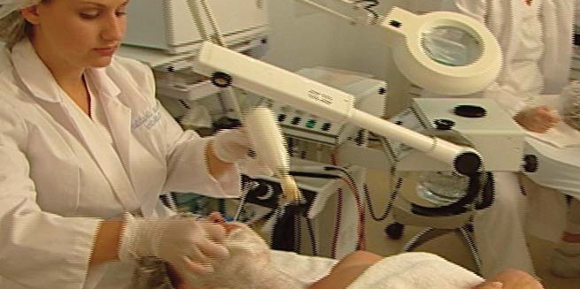

BASIC ESTHETICS PROGRAM
(600 HOUR COURSE)

Overview
The Basic Esthetics Program prepares you for a career at day and resort spas, full-service salons and skin care clinics. The course covers all aspects of skin care,
make up and holistic health and consists of 600 clock hours of technical instruction this includes lecture, demonstration and classroom participation.
Within the 600 hour course there is a minimum 220 hour externship required.

Successful completion of this course and State licensure allow the esthetician to perform both manual and electronic facials, eyebrow shaping, hair removal (other than by electrolysis), make up artistry and skin care product representation.

The program is offered as a 20-week full time format (32 hours per week), a 25-week part time format (24 hours per week) and On-Line Classes. Contact admissions for day, night and weekend schedules.

Prerequisites
Prospective students must submit a completed application and registration fee. Proof of a high school diploma, GED or college transcript must be provided.
A placement test and essay must be completed and submitted.

Enrollment
Upon acceptance, your deposit ensures a seat in the class and is applied in full towards tuition and fees. Classes fill early, so don’t delay.
Please call for tuition and fee information.

Overview

This is your opportunity to become a member of the world’s fastest growing in- dustry. The Basic Esthetics program allows you to prepare for a career with a focus on day spa, resort spa, full-service salon, destination spa and skin care clinic.

Prerequisites
Prospective students must submit a completed application and pay the designated registration fee. Proof of a high school diploma, GED or college transcript must be provided. A placement test must be completed and an essay written from a best friend point of view about the applicant must be submitted.

Course Schedule
Our 600-hour program is offered in a full-time 20-week format or a part-time 25-week format. This constitutes an average commitment of 32 hours per week
for full-time and 24 hours per week for part-time. Courses are offered days, evenings and weekends.

Tuition (All Inclusive Fee)

Includes Basic Esthetics Program, Course content, registration fee, insurance
and lab fees: Total $7,839.

Enrollment
Upon acceptance, a $500 deposit ensures a seat in the class and is applied in full towards tuition and fees. Classes fill up early and a waiting list soon develops. Apply early.

Course Outline - 600 Hours

The Basic Esthetics program includes technical instruction (lecture, demonstra-
tion, classroom participation and examination) and the following minimum of
specified practical operations:

Basic Theory and Clinical:

History of skin care
- Structure of human systems
- Structure/function of skin
- Hygiene and sanitation
- Cellular structure and function
- Bacteriology and chemistry
- Dermatology and skin disorders
- Anatomy and physiology
- Nutrition and Metabolism
- Product ingredients
- Color theory
- Facial structure analysis
- Electricity and the esthetician
- Marketing and retail sales
- Business practices
- Laws and regulations

Internship:
- Client draping and preparation
- Facial massage techniques
- Facial treatments
- Exfoliation techniques
- Hair removal

Externship Requirements:
- Client draping
- Room set up
- Station set up
- Bed set up
- Infection control
- Clean up
- Answering telephone
- Schedule/confirm appointments
- Check and respond to email
- Check and respond to voice mail
- Fax documents
- Greet clients
- Check in clients
- Check out clients
- Product ordering
- Product inventory
- Product shipping
- Turn on electrical equipment

This course covers all aspects of skin care, make up and holistic health. Successful completion of this course and licensure through Virginia will allow the esthetician to perform manual and electrical facials, eyebrow shaping and hair removal other than by electrolysis, make up artistry and skin care product representation.

A Basic Esthetician has the training and scope of practice that allows the esthetician to treat the epidermis. Regulations for State of Virginia Board of Barber and Cosmetology as it applies to Basic Esthetics; The esthetics curriculum and hours of instruction in this technology shall consist of 600 hours or equivalent credit hours and shall include, but not be limited to, the following:

- Orientation and business topics - minimum of 25 hours of instruction.
  - School policies;
  - Management;
  - Sales, inventory and retailing;
  - Taxes and payroll;
  - Insurance;
  - Client records and confidentiality; and
  - Professional ethics and practices.
- Laws and regulations - minimum of 10 hours of instruction.
- General sciences - minimum of 80 hours of instruction.
  - Bacteriology;
  - Microorganisms;
  - Infection control, disinfection, sterilization;
  - Occupational Safety & Health Administration requirements;
  - Material Safety Data Sheet (MSDS);
  - General procedures and safety measures;
  - Cosmetic chemistry;
  - Products and ingredients; and
  - Nutrition.
- Applied sciences - minimum of 95 hours of instruction.
  - Anatomy and physiology;
  - Skin structure and function;
  - Skin types;
  - Skin conditions; and
  - Diseases and disorders of the skin.
- Skin care - minimum of 255 hours of instruction.
  - Health screening;

  - Skin analysis and consultation;
  - Effleurage (related movements/manipulations of the face and body;
  - Cleansings procedures; e. Masks;
- Extraction techniques;
- Machines, equipment and electricity;
- Manual facials and treatments;
- Machine, electrical facials and treatments; and
- General procedures and safety measures.
- Makeup - minimum of 65 hours of instruction.
  - Setup, supplies and implements;
  - Color theory;
  - Consultation;
  - General and special occasion application;
  - Camouflage;
  - Application of false lashes and lash extensions;
  - Lash and tinting;
  - Lash perming;
  - Lightning of the hair on body except scalp; and
  - General procedures and safety measures.
- Body and other treatments - minimum of 20 hours of instruction.
  - Body treatments;
  - Body wraps;
  - Body masks;
  - Body scrubs;
  - Aromatherapy; and
  - General procedures and safety measures.
- Hair removal - minimum of 50 hours of instruction.
  - Types of hair removal;
  - Wax types;
  - Tweezing;
  - Chemical hair removal;
  - Mechanical hair removal; and
  - General procedures and safety measures.

Looking for a career in esthetics in a spa or beauty salon? Interested in becoming a beauty writer or working for a beauty products supplier? Become an Esthetician and you’ll be qualified for a career in any of these exciting fields. You could perform esthetics services such as facials, waxing, manicures and pedicures, and makeup application. And that’s just the beginning. As an Esthetics graduate you’ll be poised for a career in the rapidly ex- panding spa industry. Or you may choose to carry on with studies in Medical Esthetics.

Some of the careers you could enter upon graduation include:
- Esthetician
- Esthetics business owner/operator
- Esthetics instructor or educator
- Beauty writer
- Salesperson for beauty product lines
- Manager of a hotel or resort spa

You could find opportunities for employment as an Esthetics Practitioner with a:
- Private spa
- Cruise ship
- Department store makeup counter
- Beauty magazine company
- Hotel spa

There are also many self-employment options that may be attractive to you, such as set- ting up your own spa or working independently from home.

Wages and Career Outlook
Esthetics is a new and growing field driven by the increased access and affordability of cosmetic and medical esthetics procedures, as well as people’s increased concern about how they look. This interest in personal appearance, coupled with higher disposable in- comes, has created an explosion in services aimed at personal care. The average starting wage for an esthetician is $10-$15/hr plus tips, which can increase wages to $20-$30/hr. According to statistics posted by the Depart of Labor there is an estimated 40% increase in job opportunities for Make Up Artist and 37% increase in Skin Care Specialist pro- jected by the year 2016.

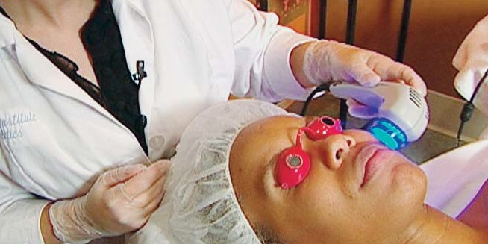

MASTER ESTHETICS PROGRAM
(600 HOUR COURSE)

Overview
The Master Esthetics Program prepares you for employment at skin therapy centers, skin care clinics, medical spas, plastic surgery, cosmetic and dermatological practices.
The course consists of 600 clock hours of instruction, with detailed training on state-of-the-art skin care equipment and protocol.
Students practice upon each other and, with proficiency, patients in a supervised clinic. The course includes chemical exfoliation, microdermabrasion, lymphatic drainage and advanced make up artistry, among others.

Students who successfully complete the Master Esthetics Program will be eligible for Masters licensing (highest) in the state of Virginia.
Contact admissions for current full and part time formats and for day, night and weekend schedules.

Prerequisites
Prospective students must submit a completed application and registration fee. Proof of a high school diploma or GED must be provided.
Completion of, or test-out of, the Basic Esthetics Program is required for the Masters Program. Considerations also include out-of-state licenses and work experiences that qualify in Virginia for basic esthetics licensing.
Each applicant will be considered on a case by case basis.

Enrollment
Upon acceptance, your deposit ensures a seat in the class and is applied in full towards tuition and fees. Classes fill early so don’t delay.
Please call for tuition and fee information.

Overview

The Master Course provides com- plete and detailed training on state of the art equipment and thoroughly covered in sequence. Students will practice on each other until profi- ciency is achieved; students will then practice on clients in a supervised set- ting.

Tuition (All Inclusive Fee)

Includes Master Esthetics Program, Course Content, registration fee, Insurance and lab fees:
Total $7,839.
Enrollment
Upon acceptance, a $1,000 deposit ensures a seat in the class and is ap- plied in full towards tuition and fees.

Course Outline - 600 Hours

The Master Esthetics program in-
cludes technical instruction (lecture,
demonstration, classroom participa-
tion and examination) and the fol-
lowing minimum of specified
practical operations:
General Concepts:
- Infection
- Bacteria
- Sanitation
- Cleansing, disinfection and
sterilization
- Material disposal, non-disposal
- Cardio pulmonary resuscitation
- Client protection
- Insurance
- Record Keeping
- Positions
- Salon Policies
- Retail marketing
- State regulations/scope of practice
- Contagious disease
- Personal Hygiene
- General cleansing and sanitation
- Professionalism
- Salon management

Anatomy and Physiology:
- History of skin
- Histology
- Tissues and systems
- Skin structure
- Glands of the skin
- Hormones
- Immune system
- Skin penetration
- Skin conditions and characteristics

Skin cancer
  - Nutrition
  - Metabolism
  - Vitamins and herbs
  - Dermatology
  - Medical professionals
  - Medically treated conditions
  - Prescription drugs
  - Esthetic medical treatments
  - Medical and esthetic terminology

Skin Treatments:
  - Facial and body massage
  - Benefits
  - Preparation
  - Manipulation
  - Disinfection and sterilization
  - Massage types; lymph drainage,
reflexology, shiatsu, Swedish
  - Facial and body treatments
  - Skin types
  - Treatment protocol
  - Extractions
  - Aromatherapy
  - Essential oils
  - Masks
  - Indications and contraindictions
  - Esthetic and facial equipment
  - FDA classification of equipment
  - Clinical treatments
  - Chemical peels and microderm
- Manual lymphatic drainage
- Pre- & post-operative treatments
- Cosmetic chemistry

Make Up:
- Purpose and effects
- Application types: day, evening,
wedding, etc.
- Face structure
- Camouflage
- Permanent make up
- Supplies and implements
- Products
- Brushes
- Safety measures
- Disinfection and sanitation

A Master Esthetician has the training and scope of practice that allows the estheti- cian to treat the epidermis. Regulations for State of Virginia Board of Barber and Cosmetology as it applies to Master Esthetics; The esthetics curriculum and hours of instruction in this technology shall consist of 600 hours or equivalent credit hours and shall include, but not be limited to, the following:

- Orientation, advanced business subjects, and infection control - minimum of 45 hours of instruction.
  - School policies and procedures;
  - Professional ethics and practices;
  - Ethics and professional conduct;
  - Insurance and liability issues;
  - Confidentiality and Health Insurance Portability and
Accountability Act of 1996 Privacy Rule (HIPAA);
  - Client records and documentation;
  - Microbiology and bacteriology;
  - Infection control, disinfection, and sterilization;
  - Occupational Safety and Health Administration (OSHA), U.S.
Food and Drug Administration (FDA); and Material Safety Data
Sheet (MSDS); and
  - Personal protective equipment.
- State laws, rules and regulations - minimum of 10 hours of instruction.
- Advanced anatomy and physiology - minimum of 65 hours of instruction.
  - Advanced anatomy and physiology;
  - Advanced skin structure and functions;
  - Advanced skin typing, and conditions;
  - Advanced disease and disorders;
  - Advanced cosmetic ingredients;
  - Pharmacology; and
  - Advanced homecare.
- Advanced skin care and modalities - minimum of 90 hours of instruction.
  - Introduction to microdermabrasion and dermaplaning;
  - Indications and contraindications for crystal microdermabrasion;

STATE BOARD OF VIRGINIA

  - General procedures/safety measures for crystal microdermabrasion;
  - Indications and contraindications for crystal-free
microdermabrasion and dermaplaning;
  - General procedures and safety measures for crystal-free
microdermabrasion and dermaplaning;
  - Equipment safety: crystal and crystal-free microdermabrasion and
dermaplaning;
  - Waste disposal, Occupational Safety and Health Administration;
  - Introduction to microdermabrasion techniques/proper protocols;
- Machine parts, operation, protocols, care, waste disposal and safety;
- Practical application/consultation for crystal microdermabrasion;
- Practical application and consultation for crystal-free
microdermabrasion and dermaplaning; and
- Pretreatment and posttreatment for microdermabrasion.
- Advanced procedures and chemical exfoliation - minimum of 270 hours of
instruction.
  - Advanced skin analysis and consultation and health screening and
documentation;
  - Advanced procedures, light treatments, light-emitting diode (LED),
intense pulsed light device (IPL);
  - Advanced manual, machine, and electric treatments, microcurrent,
and ultrasound;
  - Introduction to chemical exfoliation and peels of the epidermis;
  - Fundamentals of skin care associated with chemical exfoliation and
peels and wound healing;
  - Pretreatment and posttreatment for chemical exfoliation and peels;
  - Assessing suitability and predicting chemical exfoliation efficacy;
  - General practical application and consultation protocols;
  - Practical application and consultation for enzymes, herbal
exfoliations, and vitamin-based peels;
  - Indications and contraindications for enzymes, herbal exfoliations,
and vitamin-based peels;
  - General procedures and safety measures for herbal exfoliations, and
vitamin-based peels;

MASTER ESTHETICIAN TRAINING

Pretreatments and posttreatments for herbal exfoliations, and vitamin-based peels;
  - Practical application and consultation for alpha hydroxy peels;
  - Indications and contraindications for alpha hydroxy peels;
  - General procedures and safety measures for alpha hydroxy peels;
  - Pretreatment and posttreatment for alpha hydroxy peels;
  - Practical application and consultation for beta hydroxy peels;
  - Indications and contraindications for beta hydroxy peels;
  - General procedures and safety measures for beta hydroxy peels;
  - Pretreatment and posttreatment for beta hydroxy peels;
  - Practical application and consultation for Jessner and Modified
Jessner peels;
  - Indications and contraindications for Jessner and Modified Jessner
peels;
  - General procedures and safety measures for Jessner and Modified
Jessner peels;
  - Pretreatment and posttreatment for Jessner and Modified Jessner
peels;
  - Practical application and consultation for trichloracetic acid peels;
  - Indications and contraindications for trichloracetic acid peels;
aa. General procedures and safety measures for trichloracetic acid
peels; and
bb. Pretreatment and posttreatment for trichloracetic acid peels.
- Lymphatic drainage - minimum of 120 hours of instruction.
  - Introduction to lymphatic drainage;
  - Tissues and organs of the lymphatic system;
  - Functions of the lymphatic system;
  - Immunity;
  - Etiology of edema;
  - Indications and contraindications for lymphatic drainage;
  - Lymphatic drainage manipulations and movements;
  - Face and neck treatment sequence;
  - Lymphatic drainage on the trunk and upper extremities;

  - Lymphatic drainage on the trunk and lower extremities;
  - Cellulite;
  - Using lymphatic drainage with other treatments; and
  - Machine-aided lymphatic drainage.

A licensed esthetics school with an approved esthetics program may conduct an assessment of a student’s competence in esthetics and, based on the assessment, give a maximum of 300 hours credit towards the requirements specified in sub- section B of this section and 18VAC41-70-200 A. A licensed esthetics school with an approved master esthetics program may conduct an assessment of a stu- dent’s competence in master esthetics and, based on the assessment, give a max- imum of 300 hours credit towards the requirements specified in subsection C of this section and 18VAC41-70-200 B.

The school shall make the assessment based on a review of the student’s transcript and the successful completion of a board-approved competency examination ad- ministered by the school. The school may also request a copy of a catalog or bul- letin giving the full course description when making the evaluation. The number of credit hours awarded shall not exceed the actual hours of instruction verified on the transcript or the number of hours specified in the board-approved curricu- lum for a specific topic.

As a graduating Medical Esthetician you’ll be qualified for a highly rewarding career working in a spa, medical spa or cosmetic dermatology/surgery practice. You’ll be a re- spected specialist in a field that is growing rapidly. This $6 billion industry is growing due to the demands of baby boomers and consumers increasingly recognizing the value of cosmetic and esthetic services. There’s much more to learn about this exciting field and how you can become a part of it.

As a Medical Esthetician, you’ll be qualified to provide advanced esthetic services such as microdermabrasion, advanced chemical peels and embrace various other skin rejuve- nation technologies. Some of the careers you could enter upon graduation include:
- Medical esthetician in a spa
- Medical esthetician in a cosmetic dermatology/surgery practice
- Esthetician
- Esthetics instructor or educator
- Beauty writer
- Salesperson for beauty product lines
- Manager of a hotel or resort spa

You’ll find opportunities for employment as a Medical Esthetics Practitioner in a:
- Private spa
- Medical spa
- Cosmetic dermatology/surgery practice
- Laser skin treatment and hair removal clinic
- Doctor’s office offering hair removal
- Hotel or resort spa

There are also many self-employment options that may be attractive to you, such as set- ting up your own spa or working independently from home.

Wages and Career Outlook
Esthetics is a new and growing field driven by the increased access and affordability of cosmetic and medical esthetics procedures, as well as people’s increased concern about how they look. This interest in personal appearance, coupled with higher disposable in- comes, has created an explosion in services aimed at personal care. The average starting wage for an esthetician is $10-$15/hr plus tips, which can increase wages to $20-$30/hr. According to statistics posted by the Depart of Labor there is an estimated 40% increase in job opportunities for Make Up Artist and 37% increase in Skin Care Specialist pro- jected by the year 2016.

Benefits

Indications And Contraindictions (Pros and Cons)

Pre-Procedure (Preparation)

Procedure

Post-Procedure

Maintenance

Teaching Philosophy
The Virginia Institute of Esthetics teaching philiosophy was developed by L.
Saphonia Gee and incorporates a distinct blend of Montessori teaching methods
combined with adult experiences. While allowed to learn at their own pace, students
will find that they actually cover more information in a shorter period of time. Every
student must declare a major and minor course of study in the program, maintaining a
90% grade average before specializing in their minor. To provide individualized
attention and a quality educational experience, we accept approximately 8 students
per class.

Teaching Techniques
Technical Instruction: Instruction by demonstration, lecture, classroom participation, use of textbooks and related material, writing outlines, classroom use of audio/visual film, DVD’s, tapes, slides and examinations.
Practical Operations: Performance by the student of complete services on another person and externship.

Program Content
Technical instruction is provided to students prior to performing client services. Students will read assigned textbook chapters, attend lectures and demonstrations, prepare written procedures, perform practical operations on other persons, and participate in group dis- cussions.

Grade Requirements
Students are required to pass tests with a score of 80% or better. Those who do not are placed on a 30-day probationary period. If they achieve passing grades during that period they are taken off probation. If not, a student may face expulsion.

Learning Strategy
Each unit of instruction is divided into 3 levels of instruction.
Level One (100 hrs): An introduction to Esthetics including a brief outline of the infor-
mation to be covered, followed by an 8 week overview of analysis and protocol. Students
will select a minor at this time.
Level Two (350 hrs): A combination of theory and practical operations with a focus on
make up, product ingredients, hair removal, body therapy equipment and incorporate
the internship program.
Level Three (150 hrs): An introduction to business and internship portion of training.
Students will continue with theory and practical operations.

